Card Connect: Integrated RFID-Based Cash Savings System with Web-Based Real-Time Balance Monitoring

Submitted by:

Cunanan, Jaira
Doroteo, Rose Ann
Pedernal, Lhey Ann
Villanueva, Aizelle

May 8, 2026
Table of Contents

Project Overview 3
Project Description 3
Problem Statement 3
Objectives 4
General Objective 4
Scope and Limitations 4
Scope of the Study 4
Limitations of the Study 4
System Architecture 5
Architecture Description 5
Data Flow 6-7
Hardware Components 8
Software Components 9
Functional Requirements 9-10
Non-Functional Requirements 10
Database Design (Sample Fields) 11
System Operation Procedure 11-12
Gantt Chart 12-13
Expected Output 13

Project Overview

Project Description

The Card Connect system functions as an access control system which uses RFID technology to authenticate users through its initial step. Users have the ability to register multiple RFID devices which include RFID key fobs and card to create backup access methods for situations when their primary device becomes lost or inaccessible. The scanning of an RFID device enables the system to obtain its unique identifier (UID) which requires the user to enter their password or PIN for verification purposes. After users complete authentication successfully, the system presents them with three available functions which include Transaction and Check Balance and Open. The Transaction option enables users to handle cash transactions through both deposits and withdrawals which require users to complete a second RFID verification step to enhance security measures. The Check Balance function allows users to monitor their current savings balance which displays real-time information while the Open function uses a locking mechanism to unlock the container or access point. The system provides additional security through its deactivation function which enables administrators to deactivate lost or stolen RFID devices without impacting user account access. The system requires users to complete a secondary RFID scan before they can perform any menu functions which prevents unauthorized individuals from accessing system operations. The system establishes secure cash savings and access control through its combination of RFID technology and PIN verification methods and multiple device authentication processes and controlled access systems.

Problem Statement
The traditional cash savings systems together with access-controlled systems face security threats because they lack secure multi-layered authentication systems and real-time monitoring capabilities. The traditional savings containers do not enable users to check their account balances and transaction details at any time.The study aims to address the following problems:
- Security Risks
Systems that rely on single-factor authentication are vulnerable to unauthorized access, increasing the risk of misuse and loss of funds.
- Lack of Real-Time Monitoring
Traditional savings systems do not provide real-time visibility of balances and transactions, making it difficult for users to track their savings accurately.
- Transaction Errors
Manual and semi-automated processes are prone to errors in recording deposits, withdrawals, and balance updates.
- Unauthorized Access
Without multi-layered verification such as RFID and PIN confirmation, unauthorized individuals may gain access to sensitive functions like balance checking or opening the savings container.
- Limited Automation and Integration
Many existing systems fail to utilize IoT and web-based technologies for secure, automated, and real-time transaction monitoring and data management.

Objectives

General Objective
To develop Integrated RFID-Based Cash Savings System with Web-Based Real-Time Balance Monitoring.
Specific Objectives
The study aims to achieve the following specific objectives:
- To design a system that requires an initial RFID scan before prompting the user to enter a PIN for authentication.
- To implement a menu interface with options such as Transaction, Check Balance, and Open after successful login.
- To ensure that each menu selection requires RFID confirmation to prevent unauthorized use.
- To enhance overall security by combining dual layer authentication methods in one system.
- To support multiple RFID devices of the user and implement a deactivation feature for lost or compromised RFID tokens.

Scope and Limitations

Scope of the Study
This project focuses on developing a secure access control system that combines RFID tag (Key Fob or Card) scanning with PIN verification. The system is designed to provide controlled access through a simple menu interface, ensuring that only authorized users can perform specific actions after multiple verification steps. While this prototype addresses key security features, it also has certain limitations related to hardware capabilities and functionality scope.
Specifically, the scope of the study includes the following:
- Utilizes RFID key fob or card for initial user identification.
- Requires PIN entry after successful RFID authentication.
- Provides menu options: Transaction, Check Balance, and Open.
- Requires secondary RFID confirmation for each selected menu action.
- Supports single-user interaction per session.
- Allows activation and deactivation of RFID devices
The study is limited to demonstrating the technical feasibility and effectiveness of the proposed Card Connect system as an RFID-based cash savings and access solution. It does not aim to replace all existing financial or transaction systems but rather to provide a functional prototype that can be adapted or expanded in the future.

Limitations of the Study
Despite its intended functionality, the proposed system has several limitations that should be acknowledged.
Specifically, the limitation of the study includes the following:
- Authentication Methods: Only RFID and PIN verification are implemented; biometric or alternative methods are not included.
- Single-User Limitation: Cannot handle multiple users performing transactions simultaneously.
- Internet Dependency: Web-based monitoring requires stable internet connectivity.
- Security Reliance: Security depends on the secrecy of PINs and physical security of RFID Tags.
- Currency and Hardware Constraint: The system is strictly limited to Philippine coin denominations (₱1, ₱5, ₱10, and ₱20) and does not support paper bills.

System Architecture
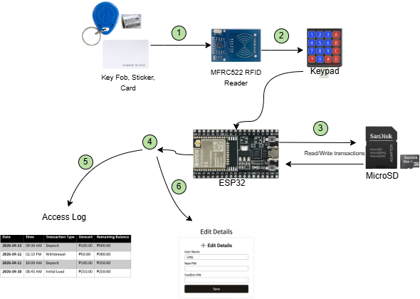

Figure 1: System Architecture

Architecture Description
The system architecture illustrates a multi-layered security framework designed for secure cash savings and access control. By integrating an ESP32 Central Controller with dual-input peripherals and a local database, the system addresses security risks and transaction errors through a strict, sequential authentication workflow.
1. RFID Data Acquisition
The RFID tag (Key Fob or Card) activation process starts when the user taps it on the MFRC522 RFID Reader. The reader system captures the user unique identifier (UID) which it sends directly to the ESP32 microcontroller. This functions as the system's first identification layer.
2. Keypad PIN Entry
The user needs to input their security PIN through the 4x4 Keypad after the RFID tag recognition process. The input is transmitted to the ESP32 system to function as a second authentication method. The system contents stay protected because this step requires a numerical code which must be entered whenever someone tries to access its contents.
3. Local Data Storage (microSD Card)
The ESP32 uses microSD card module connections to execute its Read/Write operations. The system keeps user credentials and transaction records in local text files which are named users.txt and log.txt. The system operates without internet access because local storage enables data retention during power failures.
4. Embedded Web Server
The system monitoring and management functions of the system use the embedded web server which the ESP32 provides as its main operational interface. Users who have permission can see the system dashboard.
5. Access Log Viewing
The system shows the Access Log page where it retrieves log data from the log.txt file to display it in a table that users can read. The system allows users to watch transaction records as they happen, which show the Date, Time, Transaction Type, Amount, and Remaining Balance information.
6. User Detail Management
The system features an Edit Details interface that allows for the management of account information. Users can change their registered User Name and PIN through the web-based form. The users can update system firmware through their existing file system without needing to edit files or upload new versions.
The architecture integrates RFID-based identification, PIN verification, local data storage, and a self-hosted web server within a single ESP32 device. This design reduces system complexity, avoids dependency on external cloud services, and enables real-time transaction monitoring and user management within a local network.

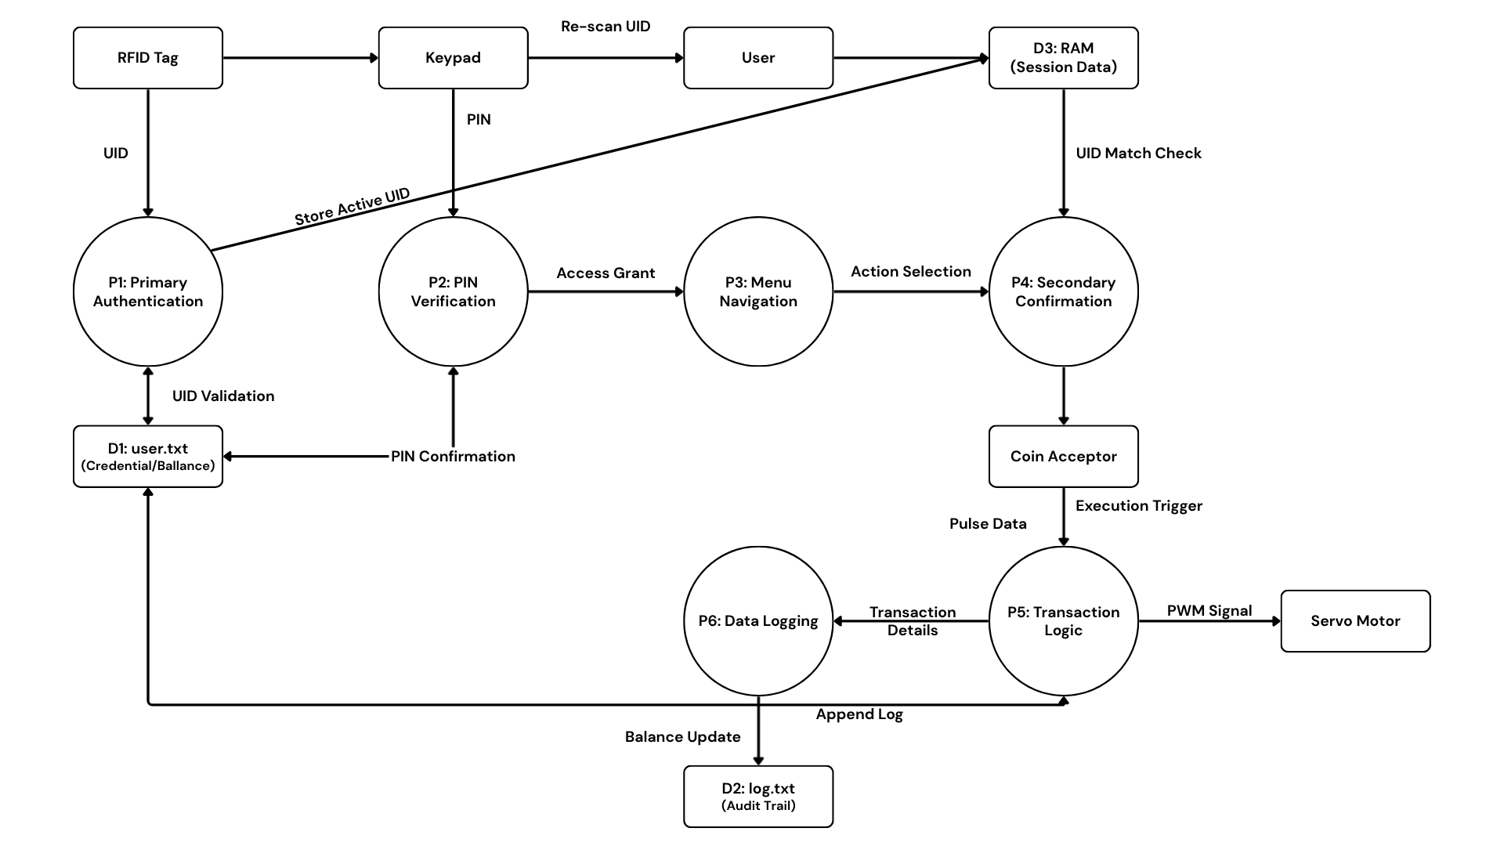
Data Flow
The data flow of the Card Connect: Integrated RFID-Based Cash Savings System with Web-Based Real-Time Balance Monitoring describes how information moves inside the system—from authentication and transaction selection to processing, storage, and system control. This flow ensures security, accuracy, and reliable operation while guiding the user through a structured, multi-layered process.

Figure 2: Data Flow
- Primary RFID Authentication
The process begins when a user interfaces their RFID tag (Key Fob or Card) with the reader. The system utilizes the Unique Identifier (UID) for initial identity verification.
- Action: The reader captures the UID and transmits it to the ESP32.
- Validation: The ESP32 cross-references the UID against the authorized database.
- Logic: If the UID is recognized, the system proceeds to PIN entry; otherwise, “Access Denied” is displayed, and the system resets to the idle state.

2. Dual-Factor PIN Verification
To prevent unauthorized access via lost or stolen tags, a second security layer is required.
- Action: The LCD prompts the user for a numeric PIN, entered via physical keypad.
- Validation: The ESP32 compares the input against the encrypted credentials stored in user.txt
- Logic: Upon a successful match, the user is granted access to the Main Menu. Incorrect attempts trigger a “Wrong PIN” alert, with the system resetting after a defined number of failures.

3. Menu Navigation
Once authenticated, the session is temporarily held in volatile memory (RAM), and the LCD populates the primary service branches:
- Insert: Navigate to deposit or Withdrawal sub-menus.
- Check Balance: View current account holdings.
- Open: Trigger physical access control.

4. Secondary RFID Confirmation
To ensure intent and prevent accidental or “ghost” commands, the system requires another scan of the users RFID tag (Key Fob or Card) before executing action:
- Requirement: The user must re-scan their RFID tag.
- Logic: If the UID matches the active session, the transaction executes. A mismatch or timeout results in an immediate abort and return to the main menu.

5. Transaction Execution Paths
The system branches based on the user's specific selection.
5a. Deposit Flow
- Mechanism: The ESP32 monitors pulses from the coin acceptor.
- Calculation: New Balance = Current Balance + Inserted Amount.
- Feedback: The LCD provides real-time updates of the total as funds are detected.

5b. Withdraw Flow
- Mechanism: The user specifies an amount via the keypad.
- Logic: The system verifies liquidity. If the requested amount is greater than the available balance, the deduction is processed; if not, an “Insufficient Funds” warning is triggered.

5c. Check Balance Flow
- Mechanism: A “Read-Only” operation is performed on user.txt.
- Feedback: The current balance is displayed for 5 seconds before the system automatically reverts to the menu.

5d. Open (Unlock Container) Flow
- Mechanism: The ESP32 generates a PWM signal to the Servo Motor.
- Action: The latch shifts to the “Unlocked” position for 5 seconds before auto-locking to maintain security.

6. Data Persistence & Logging
Following any financial or physical event, the system ensures data integrity through local storage:
- State Update: The new balance is overwritten in the user.txt.
- Audit Trail: A record (UID, Action, Amount, and Timestamp) is appended to log.txt. This provides a redundant local history independent of web connectivity.

7. Session Termination
To conclude the cycle, the system performs a security wipe:
- Action: Temporary session data (UID/PIN) is cleared from RAM.
- Feedback: The LCD displays a closing message (“Thank you!”) and reverts to the “Idle” state for the next user.

Hardware Components

Component | Description | Minimum Requirements | Recommended Requirements
Microcontroller | The central brain of the system that handles authentication logic, motor control, and hosting the web dashboard. | ESP8266 Microcontroller | ESP32 DevKit V1 (Better for dual-core processing and more GPIOs)
RFID Reader | Used for the initial authentication and the secondary confirmation scan. | MFRC522 RFID Module | MFRC522 RFID Module
RFID Tags | Served as the physical key for user identification. | 13.56 MHz | 13.56 MHz
Keypad | Used for PIN/Password entry to provide the second layer of authentication. | 3x4 Matrix Keypad | 4x4 Matrix Keypad (Membrane type for slim profile)
Solenoid Lock | Electromagnetic locking mechanism that secures and unlocks the savings container or door. | 12V DC Solenoid Lock (~0.5–1A minimum) | 12V DC Solenoid Lock (1–1.5A, Metal Housing for better durability)
LCD Display | Provides visual feedback and displays the menu options (Transaction, Balance, Open). | 16x2 LCD Screen | 16x2 LCD with I2C Adapter (Reduces wiring to only 4 pins)
MicroSD Module | Used for local data logging (log.txt) and user database storage (user.txt). | MicroSD Card Adapter (SPI) | MicroSD Card Adapter with 8GB/16GB SD Card
Relay Module | Acts as an electronic switch controlled by the ESP32 to trigger the high-voltage Solenoid Lock. | 1-Channel 5V Relay Module | 1-Channel 5V Relay with Optocoupler (For better isolation and safety)
Buck Converter | Steps down the 12V input voltage to a stable 5V or 3.3V needed by the ESP32 and other sensitive sensors. | LM2596 DC-DC Buck Converter | LM2596 Adjustable Step-Down Module with digital display
Battery | Provides portable power or serves as a backup to keep the system running during power interruptions. | 12V 7Ah Lead Acid Battery | 12V Lithium-ion Battery Pack (Lighter and more compact)
Power Supply | Provides the necessary voltage to the ESP32 and peripherals. | 12V | 12V 2A-3A Power Adapter
Jumper Wires | Used for connecting the components to the microcontroller. | Breadboard wires (Male-to-Male / Male-to-Female) | High-quality Dupont Wires
Coin Acceptor / Coin Sensor | Detects and validates coins inserted by the user. | Mechanical coin slot | Electronic Multi-coin Acceptor (Programmable for different coin values)
Table 1: Hardware Components

Software Components
Software | Purpose | Minimum Requirements | Recommended Requirements
Arduino IDE | Firmware development for ESP32 (RFID, keypad, servo, LCD control) | Arduino IDE 1.8.x | Arduino IDE 2.x
Firebase | Database for storing user data, balance, and transaction logs | Firebase | Firebase
Node.js | Backend API for handling requests between ESP32 and web dashboard | Node.js v14+ | Node.js v18+
Web Browser | Access to web dashboard | Google Chrome / Edge | Latest Chrome / Edge
React.js | For front end framework for user interface | React17+ | React 18+
Expo Go | Testing and previewing the mobile app | Android 9.0+ | Latest Android Version
Table 2: Software Components

Functional Requirements
This section defines the core functionalities of the Card Connect RFID-Based Cash Savings System.
1. The system shall read RFID tag data
The system must read RFID tag using the MFRC522 module. Each card contains a unique UID that represents a user. When tapped, the system captures the UID automatically and uses it as the first authentication layer.
2. The system shall validate user credentials (RFID + PIN)
After reading the RFID UID, the system must prompt the user to input a PIN using a keypad. The system validates both the UID and PIN stored in the database (user.txt). Only matched credentials are allowed access.
3. The system shall display a secured menu interface
After successful authentication, the system displays menu options:
- Transaction (Deposit/Withdraw)
- Check Balance
- Open (Unlock)
Each option allows the user to interact with the system securely.
4. The system shall require secondary RFID confirmation
Before executing any selected action, the system must require another RFID scan. This ensures that the same authorized user confirms the action.
5. The system shall process financial transactions
The system must support:
- Deposit (add balance)
- Withdraw (deduct balance with validation)
Each transaction updates the stored balance automatically.
6. The system shall record transactions with timestamp
Every action (deposit, withdraw, access) must be recorded with:
- User ID
- Transaction type
- Amount
- Date and time
These records are saved in log.txt.
7. The system shall store data locally
The system must store:
- User credentials → user.txt
- Transaction logs → log.txt
This ensures operation even without internet.
8. The system shall provide a web-based dashboard
The ESP32 hosts a web dashboard where admins can:
- View transactions
- Monitor balances
- Manage users
9. The system shall support multiple RFID devices per user
10. The system shall allow activation and deactivation of RFID devices
11. The system shall verify RFID status (active/inactive) before authentication

Non-Functional Requirements
1. Performance
The system must respond within 2–3 seconds after RFID scan or PIN input to ensure smooth operation.
2. Security
The system must implement:
- Dual layer Authentication (RFID + PIN)
- Secondary RFID verification
- Restricted dashboard access
3. Reliability
The system must ensure:
- No data loss during transactions
- Accurate balance updates
- Continuous operation even without internet
4. Scalability
The system should support:
- Additional users
- Expanded storage capacity
- Future integration with cloud databases
Database Design (Sample Fields)
Field | Description
user_id | Unique identifier
rfid_uid | Rfid tag UID
pin | User PIN (encrypted/hashed)
name | User name
balance | Current savings
transaction_type | Deposit / Withdraw
amount | Transaction amount
timestamp | Date and time
Table3: Database Design

System Operation Procedure
Step 1: Scan RFID Tag
Scan RFID Tag

The user taps their RFID tag, and the system captures the UID. The user taps their RFID device, and the system captures the UID and verifies if it is active and registered.
Step 2: Enter PIN
Enter Pin

The system prompts the user to enter their PIN and validates the credentials.
Step 3: Display Menu
Display Menu

The system displays a menu with the following options: Transaction, Check Balance, and Open.
Step 4: Secondary RFID Confirmation
Secondary RFID Confirmation

The user scans the RFID key fob or card again to confirm the selected action.

Step 5: Process Action
Process Action

The system processes the chosen action:
- Deposit adds to the balance.
- Withdraw deducts from the balance.
- Check Balance only displays the current balance.
- Open unlocks the container.
Step 6: Save Transaction
Save Transaction

The system saves the transaction by logging all activities with a timestamp.
Step 7: Logout
Logout

The system logs out the user, resets, and returns to the idle state.

Gantt Chart
Task / Phase | Week 1 | 2 | 3 | 4 | 5 | 6 | 7 | 8
Project Planning & Proposal | ███
Documentation |  | ███ | ███ | ███ | ███ | ███ | ███
Hardware Setup & Wiring |  |  |  | ███ | ███
System Integration |  |  |  |  |  | ███ | ███
Testing & Debugging |  |  |  |  |  |  | ███ | ███
Final Evaluation & Submission |  |  |  |  |  |  |  | ███
Table 4: Jaira Cunanan’s Gannt Chart

Task / Phase | Week 1 | 2 | 3 | 4 | 5 | 6 | 7 | 8
Project Planning & Proposal | ███
Documentation |  | ███ | ███ | ███ | ███ | ███ | ███
Hardware Setup & Wiring |  |  |  | ███ | ███
System Integration |  |  |  |  |  | ███ | ███
Testing & Debugging |  |  |  |  |  |  | ███ | ███
Final Evaluation & Submission |  |  |  |  |  |  |  | ███
Table 5: Rose Ann Doroteo’s Gannt Chart

Task / Phase | Week 1 | 2 | 3 | 4 | 5 | 6 | 7 | 8
Project Planning & Proposal | ███
Documentation |  | ███ | ███ | ███ | ███ | ███ | ███
Hardware Setup & Wiring |  |  |  | ███ | ███
System Integration |  |  |  |  |  | ███ | ███
Testing & Debugging |  |  |  |  |  |  | ███ | ███
Final Evaluation & Submission |  |  |  |  |  |  |  | ███
Table 6: Lhey Ann Pedernal’s Gannt Chart

Task / Phase | Week 1 | 2 | 3 | 4 | 5 | 6 | 7 | 8
Project Planning & Proposal | ███
Documentation |  | ███ | ███ | ███ | ███ | ███ | ███ | ███
Hardware Setup & Wiring |  |  |  | ███ | ███
System Integration |  |  |  |  |  | ███ | ███
Testing & Debugging |  |  |  |  |  |  | ███ | ███
Final Evaluation & Submission |  |  |  |  |  |  |  | ███
Table 7: Aizelle Villanueva’s Gannt Chart
Expected Output
- Automated Transaction Records
All deposits, withdrawals, and access activities are automatically recorded as transaction records.
- Secure Authentication System
The combination of RFID, PIN, and secondary scan ensures strong authentication and security.
- Accurate Balance Monitoring
The system maintains accurate, real-time balance updates.
- Real-Time Dashboard Monitoring
User can view transactions via web dashboard.
- Centralized Data Storage
All records stored in structured files and database.

